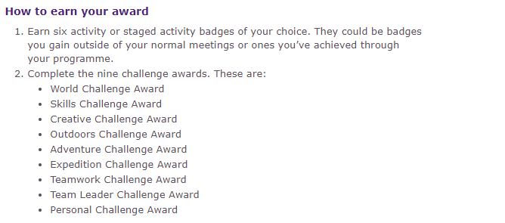
The Scout Pub Quiz Question Sheet

- Write down the standard Scout Promise. There is a Bonus Point if you can write down an alternative promise as well.
- Write all of the Scout Laws. All of them need to be correct for the point.
- What year was this Scout hall built?
- What is the technical name for this? (Show picture)
- First team to come to attention in a line.
- What are the names of all the leaders and helpers here at Chieftains? One point for each 2 first names. Bonus point for all the second names.
- Name 3 famous Scouts.
- What knot do you use to tie 2 pieces of rope together?
- What are the requirements for Chief Scout Gold?
- Name any of the countries that don't have Scouting.

- On my honour, I promise to do my best, to my duty, to God and to the queen, to help other people and to keep the Scout Law.

- A Scout is to be Trusted, A Scout is Loyal, A Scout is Friendly and Considerate, A Scout has Courage in all difficulties, A Scout belongs to the world-wide family of Scouts, A Scout makes good use of time and is careful of possessions and properties, A Scout has self-respect and respect for others.

- 1992

- Fleur de Lis

- First team to be at attention in a line standing will be awarded a point

- Peter McBride, Laurent Guiderdoni, Ben Denmeade, Orla McBride, Ellis Carne, Neil Melleaney, Jim Tobin, Simi Melleney, Jamie Wharton
- Google
- Reef Knot
- See Below
- Cuba, North Korea, China, Laos, Myanmar and Andorra.

